III Lecture: Physiology of microrganizms. Metobolism and growth.Microflora of pharmaceututecal raw materials and medicinal preparations. Effect of physical, chemical and biological factors on microorganisms. Bacteriophages. Genetics of microorganisms.

The purpose of the lecture: To inform students about the physiology of microorganisms, nutrition, metabolism and reproduction, the genetics of microorganisms and the genetic apparatus of bacteria (chromosome, plasmid, migrating genetic elements). Explain the concept of mutation and recombination in bacteria. To acquaint students with bacteriophages, their structure, properties and practical use in medicine. To acquaint students with the ecology of microorganisms, the normal microflora of the human body, its role. To inform students about the microflora of medicinal raw materials and finished dosage forms.
Lecture plan:
- Phisiology of microorganisms: metabolism, nutrition, respiration and reproduction characteristics of microorganisms. Feeding of bacteria.
- Classification of bacteria by type of food. The mechanism of passage of nutrients through the cell membrane.
- Respiration of bacteria. Classification by type of respiration.
- Growth and reproduction of microbes. Phases of reproduction.
- Reproduction of DNA and RNA. viruses. Indication and identification methods of viruses.
- Methods of cultivation, indication and identification of viruses in tissue culture, chicken embryos, laboratory animals.
- Cultivation of bacteria, cultural properties and their importance in identification
2. Ecology of microorganisms. Distribution of microorganisms in the environment.
.
3. Microflora of medicinal raw materials and finished dosage forms.
-understanding the normal microflora of plants, epiphytes and phytopathogenic microorganisms.
- microflora of ready-made dosage forms.
4. Influence of enviromental factors to microorganisms:
-physical
-chemical
- biological factors.
5. Bacteriophages:
-nature
-structure
- features.
- virulent and mild phages, defective phages. Lysogenia, its mechanism. Phage conversion.
- Application of phages in practice.
6. Genetics of microorganisms
-Organization of the genetic apparatus in bacteria and viruses. Genotype and phenotype. Bacterial plasmids and their properties.
- Modification in bacteria and viruses. Mutation and mutagenesis.
- Mutations in viruses.
- Genetic exchange and recombination in bacteria. Transformation, transduction and conjugation.
Their mechanism. Genetic recombination in viruses.

Lecture equipment: Computer, projector, electronic slides related to the lecture.
Literature. p.1

Chemical composition of microorganisms
The bacterial cell has the same general chemical pattern as the cells of other organisms. The bacterial cell contains water (70-80% of total weight), proteins, polysaccharides, lipids, nucleic acids, mucopeptides and low molecular weight compounds.
For growth and nutrition of bacteria, the minimum nutritional requirements are water, a source of carbon, a source of nitrogen and some inorganic salts. Water is the vehicle of entry of all nutrients into the cell and for the elimination of waste products.
Water. Protoplasm is from 80-85% water. The water in a single celled organism is continuous with the water of its environment and the molecules pass freely in and out of the cell, providing a vehicle for nutrients, inward and secretions or excretions, outward. All the enzymatically controlled chemical reactions that occur within the cell occur only in the presence of an adequate amount of water.
Minerals. All organisms require several metallic elements such as sodium, potassium, calcium, magnesium, manganese, iron, zinc, copper, phosphorous and cobalt for normal growth. Bacteria are no exception. The amounts required are very small.
The microbe cell utilizes nutrient substrates for the synthesis of its component parts, for storage as reserve material, for the synthesis of enzymes, pigments, vitamins, toxins, and also for obtaining energy needed for its existence.
Nitrogen. Although autortophic organisms can utilize inorganic sources of nitrogen, the heterotrophs get their nitrogen from amino acids and intermediate protein compounds such as peptides, and peptones. Beef extract and peptone, as used in nutrient broth provide the nitrogen needs for the heterotrophs grown on this medium.
All bacteria can be divided into two groups according to their type of nutrition: Autotrophic, Heterotrophic
Autotrophic (autos-self, trophe-nutrition).Which are able to produce organic substances from inorganic compounds (carbon dioxide). Autotroph- does not require organic compounds because it can synthesize them from inorganic compounds.
Chemosynthetic from them – obtain energy by oxidation sulfur and nitrogen inorganic compounds.
Photosynthetic – receive energy (ATP formation) during processes photosynthesis using energy of light – it is a cyclic phosphorylation by biochemical nature.
Heterotrophic (heteros – another) bacteria require organic carbon (sugars, amino acids etc.) and other substances (inorganic, trace elements, vitamins) for synthesis and receiving energy. All pathogenic bacteria are heterotrophic. Those bacteria can be subdivided into:
- Saprophytes which live at the expense of organic substances found in the surrounding environment and
- Parasites which living on or in another body, and feeding at its expense.

Types and mechanisms of bacteria metabolism

During Metabolism 2 opposite and at the same time indivisible processes occur: energy and constructive metabolism.
1. Catabolism - energy metabolism - processes of breakdown of nutrient substances with release of products and energy-rich compounds (Adenosine triphosphate (ATP)).
Fermentation: Glycolysis is a pathway of central metabolism that converts a molecule of glucose into 2 molecules of pyruvate and gives 2 ATP and 2 molecules of NADH During Fermentation - take place formation of ATP without electron transfer process and synthesis of specific metabolic end products which can be used for bacterial identification;
homofermentation - one end product, heterofermentation - several.
Aerobic Respiratory conversion: Tricarboxylic acid cycle (TCA) converts pyruvate into CO2 and gives 36 ATP molecules (formation during electron transfer and O2 reduction). Energy metabolism serves for the conversion of energy to a form in which it may be utilized by the cell which is used for building up the cell.
2. Anabolism - processes of synthesis of cellular constituents requiring energy. Constructive metabolism proceeds with the absorption of free energy.
Two processes (catabolism and anabolism) cannot be separated and are in fact interconnected. Metabolism is carried out with the help of enzymes.
Different types of nutrition are distinguished in microorganisms due to their absorption of carbon and nitrogen. According to the properties of carbon uptake, microorganisms are divided into two types - autotrophs and heterotrophs . Autotrophs (Greek, autos - self, trophe - nutrition) can use simple inorganic compounds - mainly carbon dioxide and other inorganic carbon compounds - to synthesize all complex organic substances containing carbon. Many bacteria that live in the soil (nitriding, serobacteria (Thiobacteria), etc.) belong to autotrophs. Depending on the use of the energy source - photoautotrophs that use light and chemoautotrophs that use organic compounds are distinguished . Heterotrophs (Greek, heteros - other, trophe - nutrition) use organic matter as a source of carbon . They assimilate carbon from carbohydrates (mainly glucose), amino acids and other organic compounds . Depending on the use of the energy source - photoheterotrophs using light and chemoheterotrophs using organic compounds are distinguished. Currently, the terms autotroph and heterotroph are replaced by the new terms organotroph and lithotroph, respectively. Lithotrophs are so named because they can grow in a pure mineral environment.
Aminoautotrophs - use either atmospheric nitrogen or ammonium salts as nitrogen sources for protein synthesis.
Aminoheterotrophs - use organic matter - amino acids and proteins as nitrogen sources. All pathogenic and most saprophytic microorganisms belong to this group.
Prototrophs are microorganisms capable of synthesizing all the substances they need using only glucose as a carbon source and ammonium salts as a nitrogen source. Auxotrophic microorganisms cannot synthesize any substance from glucose and ammonium salts, respectively, as a single source of carbon and nitrogen. Growth factors are required for their development.
Saprophytes (Greek sapros - decay, phyton - plant) receive ready-made organic substances from dead organisms.
Parasites (Greek: parasitos - omnivores, live at someone else's expense) take organic matter from living plants, animals and human organisms. Obligate and facultative parasites are distinguished. Obligate parasites are adapted to live inside the cell. For example, rickettsia and chlamydia, etc.

Nutritional mechanisms of microorganisms
Nutrients can enter a microbial cell in several ways:
Passive diffusion- Simple diffusion (due to the difference in osmotic pressures) - Facilitated diffusion (carrier proteins - permeases)
Active transport - Ion transport (uniport, simport, antiport) - ATF-transport Transport by translocation mechanism

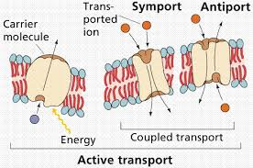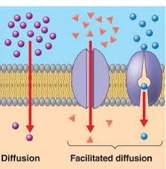
Microbial enzymes and their role in metabolism
§ Endoenzymes act within the cell, and exoenzymes are secreted from the microbial cell, breaking down the macromolecules there and making it easier for them to enter the cell.
§ Constitutional and inductive enzymes
§ Metabolic enzymes - oxyreductases, transferases, lyases, ligases, hydrolases and isomerases
§ Aggression or pathogenic enzymes - hyaluronidase, neuraminidase, lecithinase, etc.

Metabolism consists of two opposite processes - catabolism and anabolism. Catabolism is the process of breaking down large molecules into smaller molecules by releasing energy. As a result, the released energy is stored in the form of macroenergetic bonds in the molecules of adenosine triphosphate (ATF) and is used for vital processes. Therefore, catabolism is sometimes called energy metabolism. In the process of anabolism, molecular compounds used to build a cell are synthesized, so it is sometimes called constructive metabolism. This process involves the consumption of energy, which uses the energy released as a result of energy metabolism.

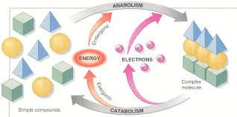

Energy metabolism (biological oxidation)
There are two types of biological oxidation (energy metabolism), depending on they are oxygenated or oxygen-free: brodil (fermentation) metabolism , oxidative metabolism
Brodil metabolism : During brodil metabolism, ATF is synthesized as a result of phosphorylation of substrates. In this case, the decomposing substrate acts as a donor of electrons, and the acceptors of the electrons are reduced, as a result of which the released energy is used for the synthesis of ATF. The process of breaking down nitrogen-free organic compounds under anaerobic conditions is called fermentation. The fermentation process consists of two stages. In the first stage, glucose is oxidized to pyruvic acid. The process of formation of pyruvic acid from glucose consists of a series of biochemical reactions. In both brodil and oxidative metabolism, this process can proceed in the same way - in three ways.
Glycolysis pathway (Embden-Meyerhof pathway) predominates in bacteria . In this case, glucose is first converted to fructose-6- phosphate, and then to pyruvic acid. During glycolysis, 2 molecules of ATF are used in the process of glucose breakdown, and 4 molecules of ATF are synthesized. Thus, 2 molecules of ATF are synthesized from 1 molecule of glucose. As a result of the reactions, phosphate is transferred from intermediate substrates to the molecule adenosine diphosphate (ADF), and thus ATF is synthesized. Therefore, it is called substrate phosphorylation.

Types of fermentation : The resulting pyruvic acid undergoes various transformations in anaerobic microorganisms, resulting in different types of fermentation, depending on the final organic matter formed.
§ Lactic acid fermentation § Alcohol fermentation § Propionic acid fermentation § Formic acid fermentation § Butyric acid fermentation
Formic acid fermentation : This fermentation is mainly characteristic of bacteria of the family Enterobacteriaceae. Many bacteria break down formic acid, which is formed during fermentation, into gas (H2 and CO2). Thus, some bacteria break down carbohydrates only to form acids, while others break them down to form both acids and gases. It is used in the biochemical identification of bacteria (use of the Hiss medium).
Butyric acid fermentation: The main products of butyric acid fermentation are butyric acids, as well as other organic acids - acetic, capron, valerian, palmitic acids, as well as butanol, acetone, isopropanol, CO2 and H2. Determination of formed acids by gas-liquid chromatography is used as an express method in the identification of obligate anaerobes. This type of fermentation is characteristic of bacteria of the genus Clostridium.
Oxidative metabolism : During oxidative metabolism, ATF is synthesized as a result of oxidative phosphorylation. In this case, pyruvic acid is completely oxidized to CO2 in the circulation of tricarboxylic acids: pyruvic acid NAD, FAD, etc. With the help of coenzymes, acetyl is converted to coenzyme A (activated acetic acid) and joined to the triacetic acid cycle (Crebs cycle).
Tricarboxylic acid cycle (Crebs cycle) : In the tricarboxylic acid cycle, acetyl groups decompose to form CO2 and 4 pairs of hydrogen atoms. Hydrogen atoms combine with NAD, NADF and FAD to reduce them to NADH2, NADFH2 and FADH2. In this way, hydrogen atoms are transferred to molecular oxygen along the respiratory chain located in the cytoplasmic membrane of microorganisms. The transfer of hydrogen atoms along the respiratory chain to molecular oxygen is provided by dehydrogenase, quinones (ubiquinone, etc.) and cytochromes.
Respiratory chain during oxidative metabolism or respiration (oxidative phosphorylation), electron donors are organic and inorganic substances, and acceptors are only oxygen. In this case, the respiratory chain:
NAD FAD cytochromes O2

Respiration of microorganisms
Microorganisms are divided into 3 main groups according to the type of respiration:
§ obligate aerobes - Microaerophiles - Capnophiles
§ obligate anaerobe - obligate anaerobes - aerotolerant anaerobes
§ facultative anaerobes

Growth and multiplication of microorganisms
As microorganisms mature, they begin to multiply .Multiplication in different microorganisms occurs in different ways . Bacteria multiply by simple, binary division. The division of a bacterial cell begins with the formation of a transverse partition. The transverse partition is provided by mesosomes.
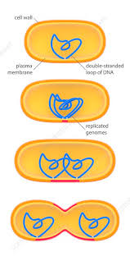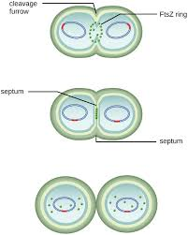

Bacteria multiply very rapidly. The concept of generation time is used to estimate the rate of multiplication. This period represents the time required for the bacterial cell to double. Generation time is different for each type of bacteria. Bacteria, and in general all microorganisms, multiply more rapidly under optimal conditions. Most bacteria divide every 15-30 minutes. Some bacteria, such as mycobacterium tuberculosis, divide relatively late (every 20-24 hours). As the bacterial cell multiplies by dividing in two, their number increases in the culture in a geometric sequence: 2 0 – 2 1 – 2 2 - 2 3 …. 2 n , so after dividing by n, the number of bacteria in a bacterial family will be 2 n . When growing under such conditions, bacteria multiply until the components needed for their development reach a minimum, after which their proliferation stops. If no nutrients are added during this period and the metabolic products are not removed, a periodic or static culture is obtained.
Phases of bacterial multiplication in periodic culture. Periodic culture behaves as if it were a multicellular organism. The multiplication of bacteria here is subject to a certain pattern and consists of several phases. The graphical description of these phases is called the development curve.

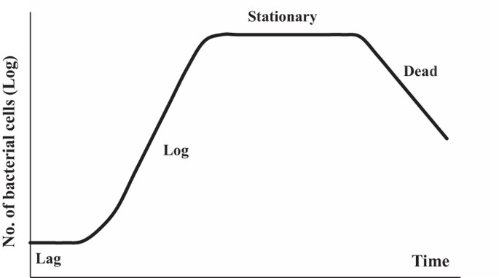

In biotechnology, conditions are created that require bacterial cells to remain in the exponential (logarithmic) phase for a long time. For this purpose, a new nutrient medium is constantly added to the culture in which the bacterial population is developing, and at the same time an appropriate amount of bacterial suspension is removed. Thus, a continuous culture is obtained. Continuous cultivation is carried out on special cultivators - chemostats and turbidostats. When cultivating in hemostats, as fresh nutrient medium is added to the cultivator, an appropriate amount of bacterial suspension is removed. Cultivation in turbidostats is based on maintaining a constant optical density of bacterial suspension in the cultivator.
A population formed by bacteria in nutrient media is called a culture .Under optimal conditions, bacteria form a unique population, which is called culture. As they grow in nutrient media, the nature of the cultures produced by each bacterial species is different. It is used in the identification of bacteria because their cultural characteristics are relatively stable.

Microflora of pharmaceutical raw materials and medicinal preparations.
While there are no publications about the use of medicines for the treatment of microorganisms and the possibility of infection.Orally taken orally administered contaminant products after 1963 caused some infections. It was understood that the drugs could also be a source of infection.Oral medications include food type infections-Salmonella, eye ointments containing P. aeruginosa, eye drops are common eye infections. In the past - when the pharmacist prepared the medicine according to the patient's prescription and consumed it in a short time. Today - the drug is being prepared in factories and used by a large patient population after a long time in the factory.
Standard, set of rules for quality production = GMP (Good Manufacturing Practice): reduce the risk of error in production to a minimum,concept that provides quality production suitable for its intended use. First introduced in 1963 by the Food and Drug Administration (FDA) in the United States. It was accepted and published by the World Health Organization (WHO) in 1968. In 1984, practiced in our country as a compulsory drug producer. The rules governing the minimum requirements of the methods, installations and controls applied to the production, packaging and presentation of a product (medicine). The aim is; it is safe to use the drug, and it ensures that it carries the desired purity and quality.
GMP; A quality system that directly influences human health is a quality system that guides the conditions under which products such as medicines, cosmetics, food, medical devices should be produced.The quality of each serial product in the production depends on its suitability to all required standards. So: adequate training of staff, provision of suitable buildings and equipment,use of the right materials, implemented trial actions, availability of suitable storage and transport equipment, correct record keeping means – GMP. Microbiological quality controls should be performed at each stage of production to minimize microbial contamination and microbial quality in pharmaceutical products and to minimize the risk of secondary infection.The microbial contamination in the pharmaceutical product causes the product and the patient's health to deteriorate, causing material and moral loss for the manufacturer.A statistically insignificant error in the medication may pose a serious hazard to the patient using the product.
Raw material properties and characteristics:
•Many drug substances and adjuvants are suitable for the proliferation of microorganisms.
•The most important factors that play a role in the microbiological contamination of medicines are natural raw materials with a broad microflora of vegetable and animal origin.
Pharmaceutical form:
•It is directly related to the microbiological contamination of a drug.
•For example; Liquid and semi-solid preparations are extremely dangerous. Antimicrobial substances such as ethanol and sugar are added to some preparations to inhibit the growth of bacterin.
•Sterile products and non-sterile products can not be produced in the same environment.
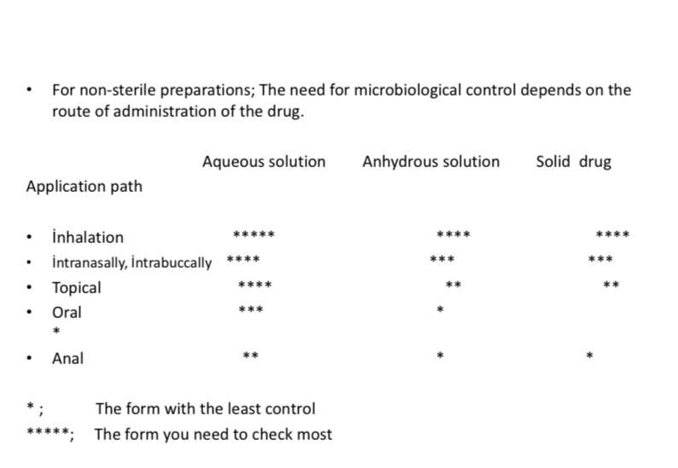
•For sterile preparations:
1. For injectable preparations: 2. For ophthalmic preparations:
* Sterility test
* Sterility test
* Pyrogenicity test
* Toxicity test
2. For ophthalmic preparations:
* Sterility test

•For non-sterile preparations:
Microbiological limit test;
1.Aqueous solutions, water / for appropriate solvent-soluble substances
-Filter filtering
2. For distributed systems (Tablet, syrup, etc.)
-Can counting bacteria
3. For small amounts of preparations containing microorganisms

•Manufacturing stage- Fabricated Hygiene:
During the manufacture of medicines
1-unsuitable environmental conditions
2-used tools and equipment
3-staff
4-Raw
5-Water
6-packaging
7-storage and waiting time to raft; the causes of

All factors that cause contamination during manufacture should be removed.The water used must comply with microbiological standards.Deionized water used for the preparation of non-injectable drugs and freshly drawn (4 hours prior) distilled water for injectable and eye preparations which must be sterile should be used after microbiological controls.Filtered air should be delivered to the area where the production is made.Trained personnel should be employed. Sterile production should be done in units built separately and purposefully from other production areas.Attention should be paid to particulate contamination during sterile production.This is why walls, ceilings and floors. Dust and other particulate matter.Provides continuous cleaning and disinfection. The surfaces must be smooth and air, non-water permeable. Staphylococcus, Micrococcus and Diphtheroid bacilli, which are present in the normal hand flow of contaminated hands by hand, cause contamination of the drug and reach the organism through contaminating drugs. Cross-contamination: Pathogenic bacteria or viruses are said to pass from a contaminant surface to another surface.Therefore, the contamination spread can be reduced by methods such as not using the spoon, needles, injectors for the second time, and disposing of the applicators after the use of the topical products - disposing of the applicators. Drugs that are kept open may be contaminating with airborne microorganisms.In terms of homes and hospitals, the drugs used in hospitals are more likely to be infected with pathogenic microorganisms.In the investigations conducted, it has been determined that the drugs are mostly in high-level contaminants during use. Bacillus subtilis, yeast in the majority of daily used tablets and the land was found
A pharmaceutical preparation;
Contains pathogenic or potentially pathogenic microorganisms.Possession of toxic metabolic residues of microorganism. In the case of obvious and obvious physical and chemical changes, the preparation is regarded as completely degraded in terms of microbiology.Contamination is the activation of the active substances in the drug and may lead to some. Types of microorganisms contained in a drug that is contamine; Air, water, human, animal and vegetal fluoride.Aeropers are the dominant microorganisms. The majority, except Bacillus anthracis, are saprophytic bacteria. Sports forms are particularly resistant to heat and antimicrobial agents. Gram (-) basil is another group of bacteria that can be found in contaminating prep. E. coli, Klebsiella, Enterobacter, Hafnia, Serratia, Citrobacter, Salmonella, Proteus and Pseudomonas group microorganisms. Most of these microorganisms are opaque (opportunistic, potential pathogen). These bacteria, which are found in human and animal normal microflora, gain pathogenicity . Yeast and Mold (Aspergillus, Penicillium, Saccharomyces) Are among the microorganisms encountered in medicines and most of them are heat resistant.
Microbial contamination can lead to drug degradation and result in subpotency. Patients can be exposed to pathogens or opportunistic microorganisms that can cause serious metabolic harm or lead to a patient’s death, especially if the patient is immunocompromised. Other microorganisms can produce harmful microbial toxins that can cause serious patient harm and death.

Bacteriophages
Reproduce in bacteria and other microorganisms and in special conditions cause their lysis. First was observed in 1917 F.D’Еrеll when he detected lysis of pathogen obtained from patient with dysentery by filtrate obtained from stool specimen of the same patient. D’Еrеll concluded that factor causing the lysis is a virus which can pass through bacterial filterHe called this virus as bacteriophage(«eating bacteria»), and phenomenon - as baceriophagy . Phage sizes are similar to other viruses and vary between 20- 800 nm. They have thread, cube and spermatozoid like morphology. E.coli phages have been (T phages) studyed well. T (typе) group phages are represented by 7 members, 4 of which single (T1, T3, T5, T7) and paired 3 (T2, T4, T6). Paired T phages, especially T2 have complex structure. Due to character of interaction with bacterial cell phages divided to virulent and temperate one.
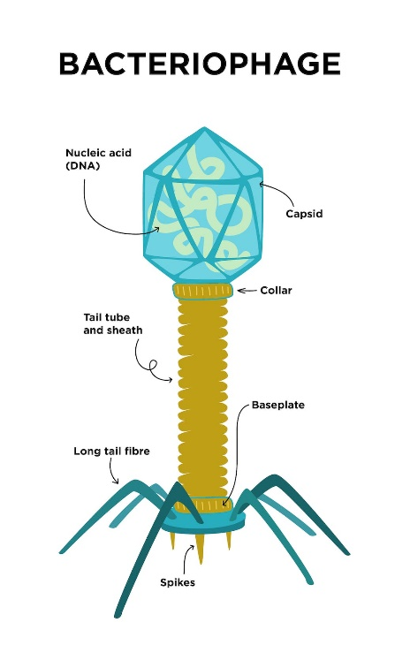
Virulent phages enter and reproduce in bacterial cell causing its death – lysis. It is represented with loss of turbidity of microorganism broth culture -phage lusate. In solid nutrition media they visible by eyes zones of lysis – phage negative colonies.
Interaction of virulent phage with bacterial cell: 1. Adsorption of phage to bacterial cell 2. Entrance of phage nucleic acid inside the bacteria 3. Reproduction of phage nucleic acid and protein synthesis 4. Assembly of phage 5. Release of phage from the cell
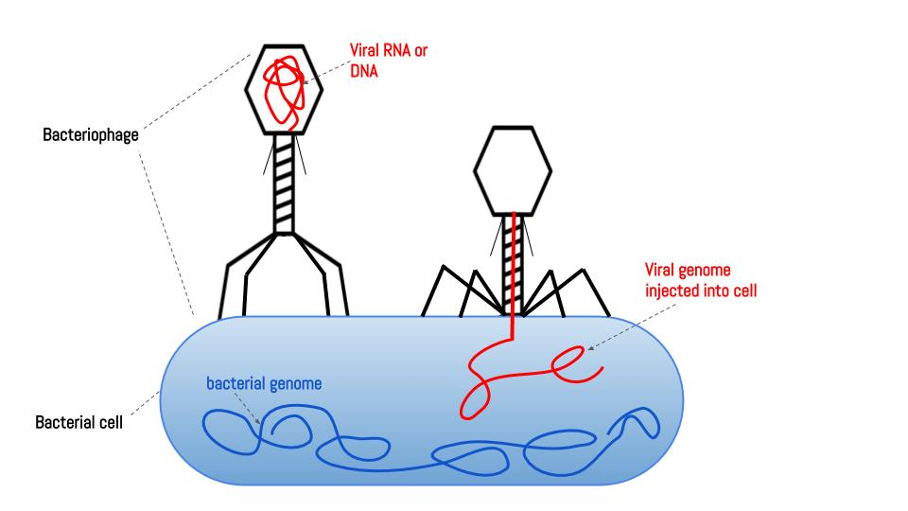
After entering the bacterial cell nucleic acid of temperate phage integrate with bacterial cell chromosome. It does not cause lysis of bacterial cell. Nucleic acid of phage connected to chromosome is called prophage. Symbiosis of bacterial cell with phage is called lysogeny while bacteria is called lysogenic bacteria. Prophage of lysogenic bacteria is able to disintegrate from chromosome and become virulent phage. At this circumstance phage causes lysis of bacteria. The process of conversion prophage to virulent is triggered by various factors, especially by radioactive rays.
During lysogeny with defective phage possessing genes responsible for some features lysogenic bacteria obtain new features. Defective phages temperate phage wich are unable to carry out complete infectious cycle. Using this way bacteria can obtain ability to produce toxins, new antigens, morphological features, etc. It is called phage conversion or lysogenic conversion. They are used in genetic engineering as transductive phages.

Genetics of microorganisms.
Hereditary information in bacteria can exist in nucleoid(chromosome), plasmids – extrachromosomal structures, and in migrating genetic elements. The material basis of heredity is DNA. All features of organism are coded in DNA in form of nucleotide sequences. Only in some viruses (RNA viruses) the genetic information is coded by RNA. DNA molecule is formed by two spiral strands(chains). Each strand of the DNA is formed by nucleotides.
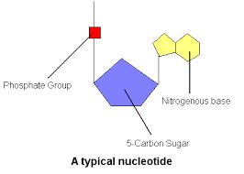
Nucleoid consists of one circular chromosome(haploid) with approximately 4000 genes. Duplication of chromosome is always associated with cell multiplication. Multiplicating bacterial cell has 2-4, even 10-15 chromosomes. Single chromosome of bacteria consists of 5x106 nucleotide pairs (if compare human genome consists of 2,9x109 nucleotide pairs). The length of the chromosome of a bacterial cell (Escherichia coli) is about 1 mm. A part of DNA molecule responsible for synthesis of one protein is called gene. All organism features are coded by chromosomal genes. Structure and regulatory genes exist. Structural genes code information about protein, while regulatory genes regulate the activity of structure genes.
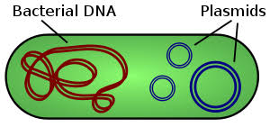
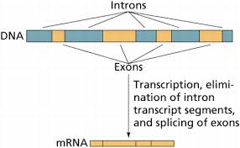
Prokaryotes in contrast with eukaryotes don’t have introns between coding genes
According to current understanding genes activilty is regulated by operon. Operon conception suggests that one gene or gene group expression is regulated by operon, in the true sense of the word, the operon supports "working“ of genes. Operon consists of regulatory gene, promotor, оperator and structural genes.
• Regulatory gene codes repressor protein with high affinity to operon DNA. - Repressor protein can bind to DNA. - Repressor protein binds and blocks transcription of gene.
Promotor consists of nucleotide sequences recognized by RNA-polymerase. Its Sfactor provides a specific connection with the promoter. Operator is area for repressor protein binding and located between promoter and structural genes.
Genotype: The whole set of cell genes comprises its genotype The genes responsible for synthesis of substance is named by initial letters of corresponding substance. For example, aminoacide arginine gene аrg+ , lactase gene - lаc+ . Susceptibility to antibiotics and phages is denoted by s (sеnsitivе), resistance – by r (rеsistаnsе). For exp., gene responsible for susceptibility to streptomycin is named as strs , for resistance – as strr.
Phenotype: Phenotype refers to observable properties of an organism. In contrast to genotype phenotype can change. Manifestation of genitype in form of phenotype is called expression. However, genotype is not always expressed. Phenotype of bacteria is named as genotype (the first letter of phenotype name is written in capital).For example аrg+ genotype corresponds to Аrg+ phenotype, lаc+ - to Lаc+ phenotype.
Some bacteria have extrachromosomal genetic elements – plasmids and migrating genetic elements. Plasmids are extrachromosomal DNA fragments consisiting of 40-50 genes. Some circular plasmids are located in cytoplasma(episomes), some – integrated to chromosome(integrated plasmids). Plasmids features: extrachromosomal DNA molecules; multiply independently of chromosome; can be transferred between bacteria; exist in circular and linearforms. Plasmids are a part of genetic apparatus of bacteria and responsible for antimicrobial resistance, toxin production, bacteriocin synthesis etc. Genes responsible for synthesis of these molecules are located in plasmids. F-plаsmids (eng, fеrtility) – participate in conjugation R-plasmids (eng, rеsistаnsе) – antimicrobial resistance tоx+-plasmids-synthesis of exotoxins (exp., diphtheria and botulism, prototoxins) Cоl+-plasmidsr - synthesis of colicin and other bacteriocins by E.coli
Small DNA fragments are able to migrate (transposition) from one chromosome to another, from chromosome to plasmid, from plasmids to chromosome. This feature is due existence in migrating elements of enzyme – transposase. Migrating genetic elements - insertion sequences (IS-еlеmеnts), - trаnspоsоns(Tn-еlеmеnts), - defective phages.

Modification: Through modification microorganisms attain morphological, cultural, biochemical changes. Modification in mоrphological features is accompanied by changes in form and size of microorganisms. Modification can be represented by changes in: cultural features, Biochemical features of microorganism Modification is manifested in microorganism population as dissociattion phenomenon.
Dissociation : During dissociation some bacteria when cultivated in solid media form different types of colonies (2 or more types). Smooth S-colonies, rough R-colоnies. Sometimes mucoid M-colonies, very small D-colonies (dwarf) are formed.
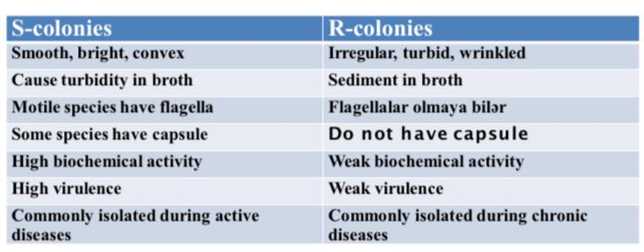
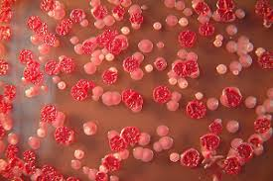
R-S dissociation

Mutation: Mutation (lat, mutаtiо - change) – occurs in chromosomes and genes. As a result of mutation microorganism can obtain or loose some features. This variability is passed on future generations. In order to distinguish strains passed through mutation from wild strains they are called mutantstrains.
Mutаtions :
Spоntаneous mutations - rеvеrsible
Inducible mutаtions - mutаgеns (chemical substances, radiation– UV, ionizing, X-rays.)
Point mutations - frameshift mutations - missеns mutations –change in aminoacide - nоnsеns mutations
Chromosome mutations(deletion, inversion, duplication)
According to phenotypic results- nеutrаl mutations, conditional lethal, lеthаl mutations

Genetic recombinations
Exchange of genes occurs between two microorganisms. An isolate passing genetic material is called donor, while isolate receiving it – recipient. During recombination recipient cell receive a part of chromosome which leads to formation of noncomplete zygote – merozygote. After recombination from recipient cell recombinant cell is formed. Thus, recombinant cell posses recipient cell genotype and some genes of of donor. Transfer of genetic material in microorganisms occur through transformation, transduction and conjugation.
Trаnsfоrmаstion – direct transfer of genetic material (DNA)from donor to recipient
Trаnsduction – transfer of genetic material (part of a DNA molecule) from a donor to a recipient by bacteriophages
Conjugation- the most frequent mechanism of transfer of genetic material. In this case, the genetic material is transferred from the donor to the recipient by direct contact.

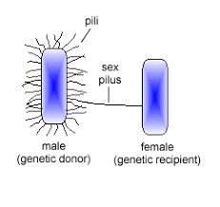
As other recombination mechanism 2 cells participate in conjugation. The donor must have F-plasmid or F-factor (fertility), and called F + cell. Since this factor is not present in the recipient cell, it is referred to as F- cell. During conjugation the F-factor is transferred to the recipient cell in almost all cases, regardless of the donor chromosome. F-factor encodes conjugative pili (F-pili). After conjugation recipient cell becomes F+-cell,which can transfer F-factor to other cells.
If F-plasmid integrates to cell chromosome it forms Hfr-cell (high frеquеncy оf). They are able to transfer chromosomal genes to recipient cells with high frequency.
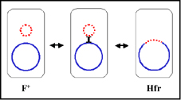

During conjugation between Hfr-strain and F – cell F-factor is not transferred, in contrast chromosome DNA is transferred with high frequency. After such conjugation, the recipient still remains an F-cell. During Hfr-conjugation chromosome DNA is replicated, as a result one strand of synthesized DNA copy is transferred to F - cell. Thus, donorstrain remains genetically stabile.
Genetics of viruses.
Viral genome consists of only one type nucleic acid - DNA or RNA. While the genome of other organisms consists of DNA, in viruses RNA also can play a genome role(RNA viruses). DNA viruses have 2-strand, nonsegmented genome with infectious properties (except Pоxvirus and Hеpаdnоvirus as their DNA strands have different lengths). Except Reoviruses and retroviruses majority of RNA viruses have single strand RNA. Genome of RNA viruses may be segmented(fragmented) or nonsegmented. Genome of positive (+RNA) viruses possess infectious properties. Genome nеgаtive (-RNA) viruses does not possess infectious properties
Types of variability in viruses :
Modification
Mutation
- Without phenotypic manifestation(nеutrаl),
- with phenotypic manifestation - lеthаl, - conditional-lethal- temperature sensitive mutants
-Increase of viral infectious spectrum
- resistance to antiviral drugs
Genetic interactions between viruses: When at the same time different viruses infect a cell they interact with each other during reproduction. Gеnеtic rеcombination is exchange of genes between two or more viruses. It is common in DNA-containing viruses, resulting in the formation of recombinant viruses with two or more parental genes. Gеnеtic rеаctivаtion occurs between to relative viruses with nonactive genes. After recombination these genes become activated (reactivation).
Nonspecific interaction between viruses :
Complementation – a protein encoded by genome of one virus supports reproduction of other virus. Complementation is observed between two defective viruses that cannot be reproduced separately, resulting in the reproduction of one or both of these viruses.
Phenotypic mixing - when a susceptible cell is infected with two different viruses, sometimes one generation of the virus has the phenotypic characteristics of the both parental viruses.
Phenotypic masking - the genome of one virus is surrounded by the capsid membrane of another virus, resulting in pseudotypes.

